Color Report

Name: Gang Ruan, Date: 5/12/2021

1. what is the difference between "warm" and "cool" colors?

Colors have different mood to people. Most mentioned moods are warm and cold. Warm color can evoke people’s passion, excitement, and energy. Cold color can make people feel calm, tranquil, and relaxing.

Warm: red, yellow, orange, brown, burgundy

Cold: blue, green, violet

Color and people:

Different color can affect people’s feeling and mood.

Different people with different personality will have different preference to different colors.

1. how does a color's effect can change depending on the other colors nearby?

This hair color bar decorated with natural marble countertop and hardwood floor, but they add purple to some walls to make contrast. To make people more feel like nature, they put product shelves with green background.

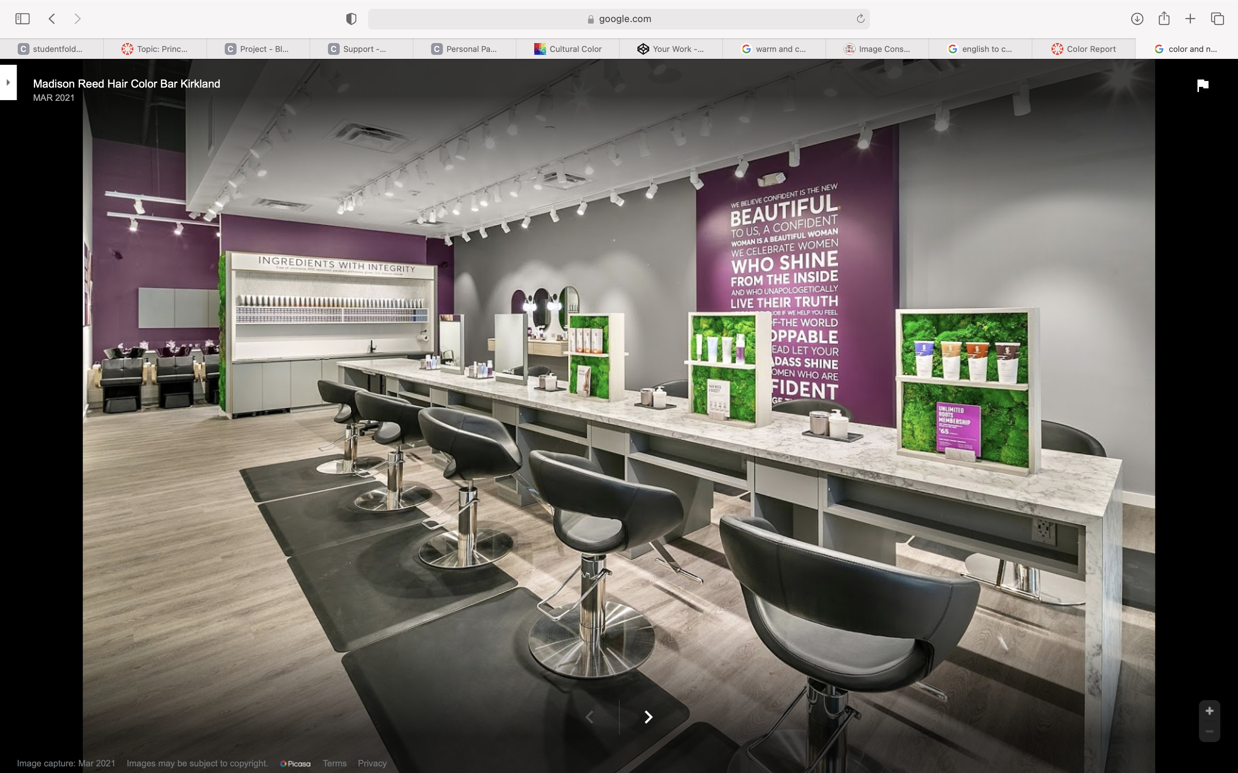

@ copyright. From Madison Reed Hair Color Bar in Kirkland

Below 3 color palette I created from DeGrave.com

1. Name: Study Room. it decorated with blue on the wall, natural hardwood floor, white ceilling with couches to make people tranquil and like to stay to take some book out of the bookshelf to read. Mood: Cold and Tranquil.

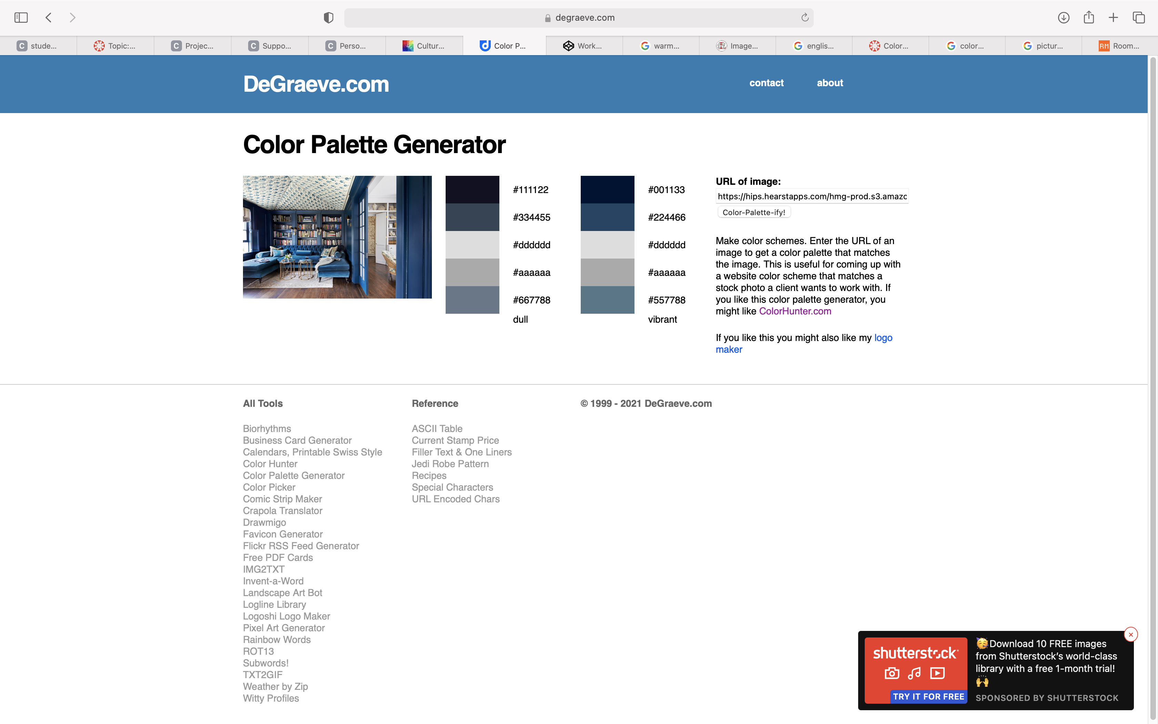

1. Name: Bird. This picture with dark and grey background, green tree leaves. The red needle tree leaves right match the color on the bird. Mood: Tranquil.

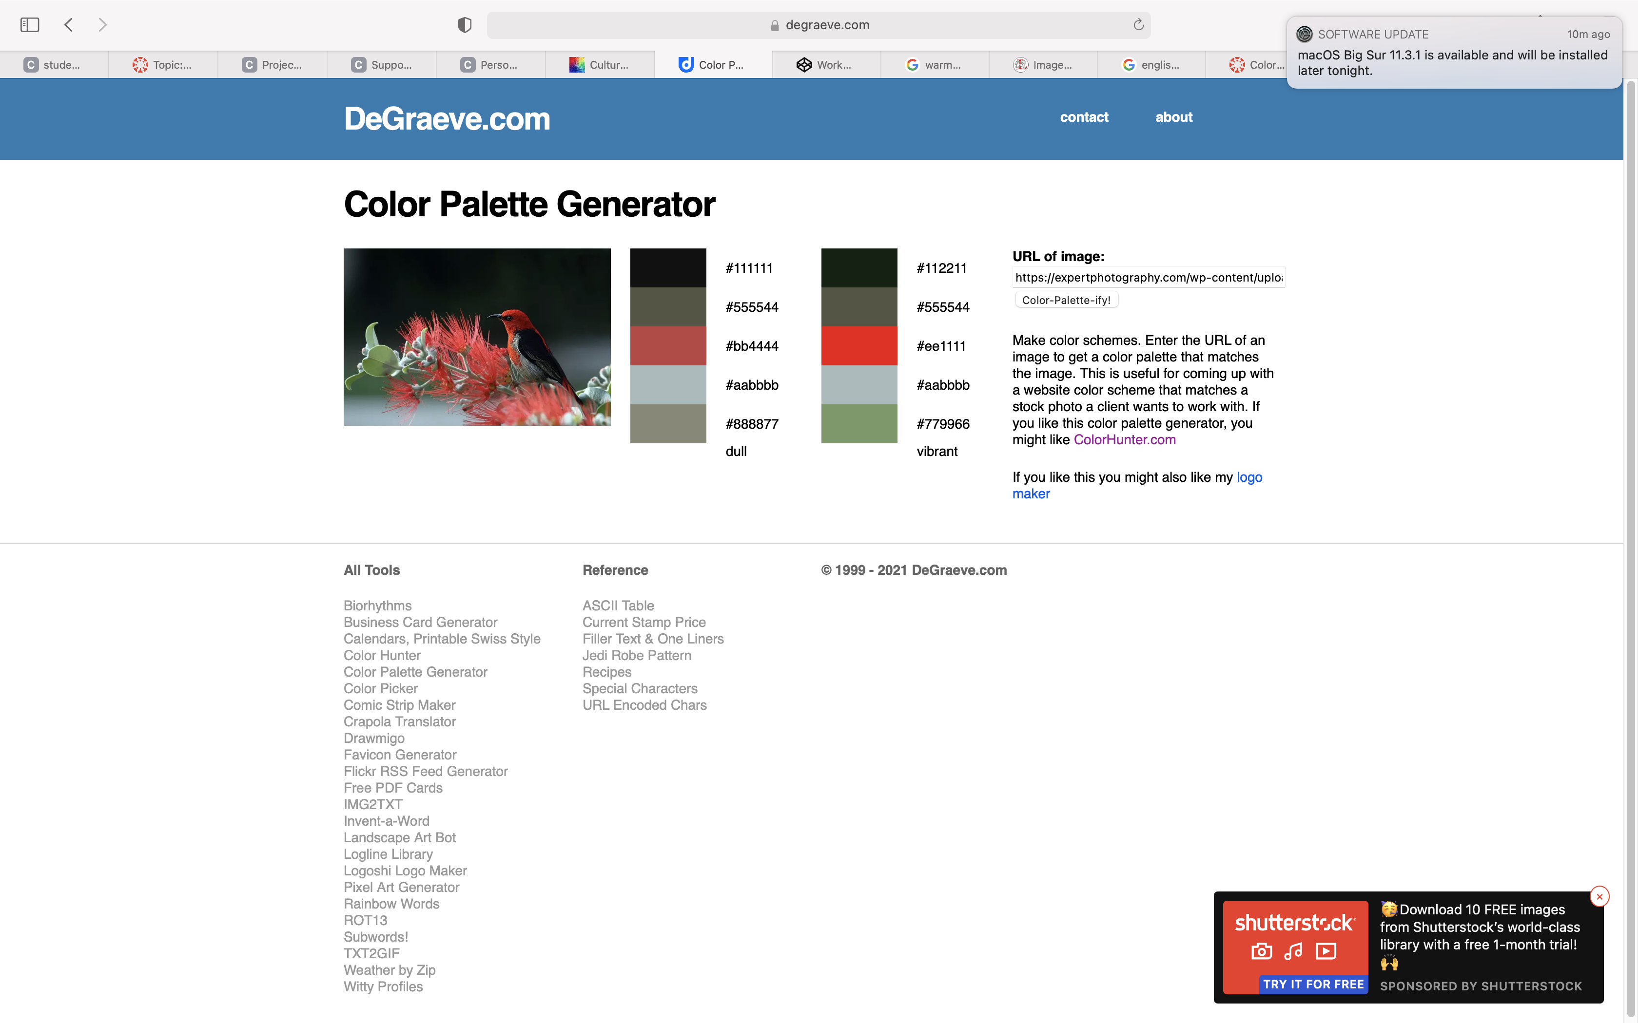

1. Forbidden City: This picture is front view of Forbidden City in Beijing. As I said, the wall is in red and roof is in golden color. This is typical royal color pattern. Mood: Warm and prosperity.

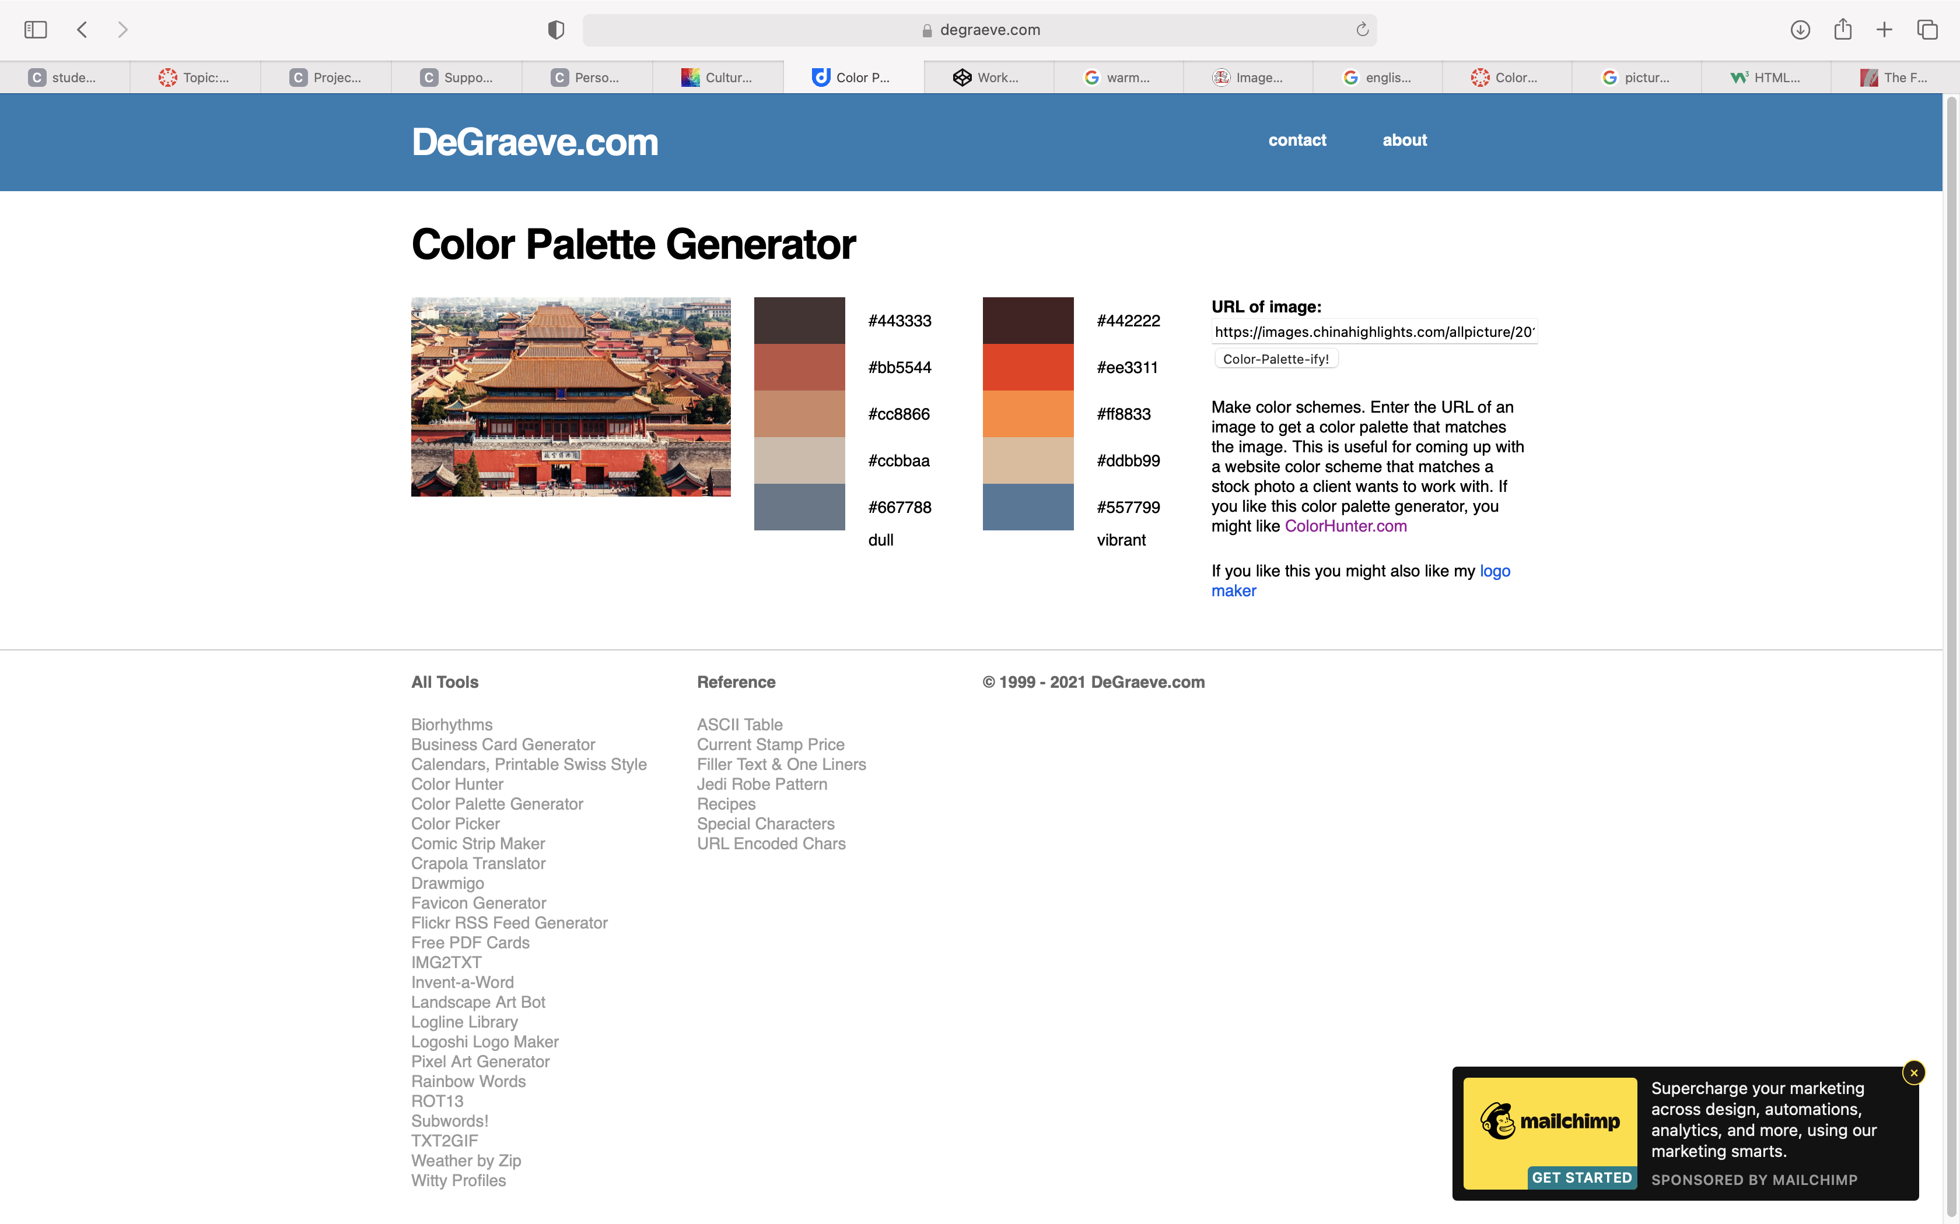

1. Name: Sunflower. This is a typical warm color with yellow sunflowers under sunshine. Mood: Warm.

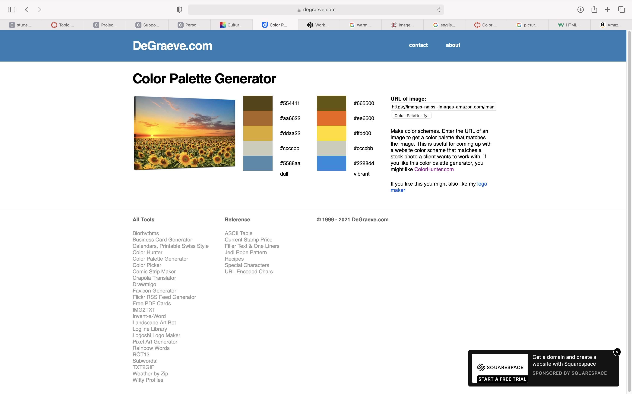

1. what are some examples of the cultural differences related to color and meaning?

People with different cultural background will have different color preference. For example, 1) In China, in Chinese Luna New Year, in the old days, people wear red clothes for happiness, celebration and prosperity. 2) When people passed away, their family usually wear in black with white belts. 3) Royal Palace: wall are red, roof is golden color, while for ordinary people, their house wall are usually in grey and white.

1. Below are 2 pictures I scanned from my calendars.

1. First picture shows sky-blue, ocean-blue with sunshine and light brown beach sand makes people tranquil, relax, ideal vacation destination.

1. Second picture shows sunset at beach with firing clouds makes people warm and still like to stay at beach at dusk.